Lab Report-5
- Implementation of Knapsack and Longest Common Subsequence (LCS) Algorithms.

Objectives
- To implement the Knapsack Algorithm using Dynamic Programming and determine the highest possible profit that can be achieved within a fixed knapsack capacity.
- To create a program for the Longest Common Subsequence (LCS) Algorithm that identifies the longest matching subsequence between two given strings.
- To gain practical experience with Dynamic Programming by solving optimization and sequence-matching problems.
- To evaluate the effectiveness of Dynamic Programming in minimizing unnecessary computations and improving algorithmic efficiency.
- Code of Knapsack:
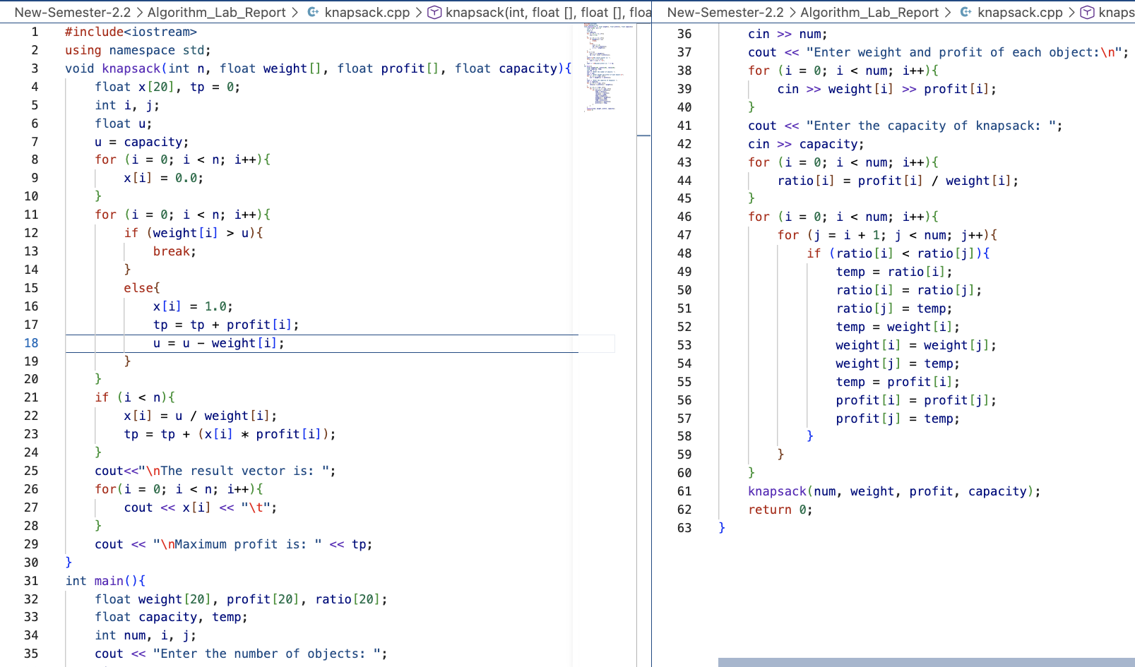

Output:

Output:
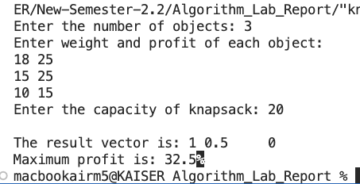

Code of LCS:

Code of LCS:
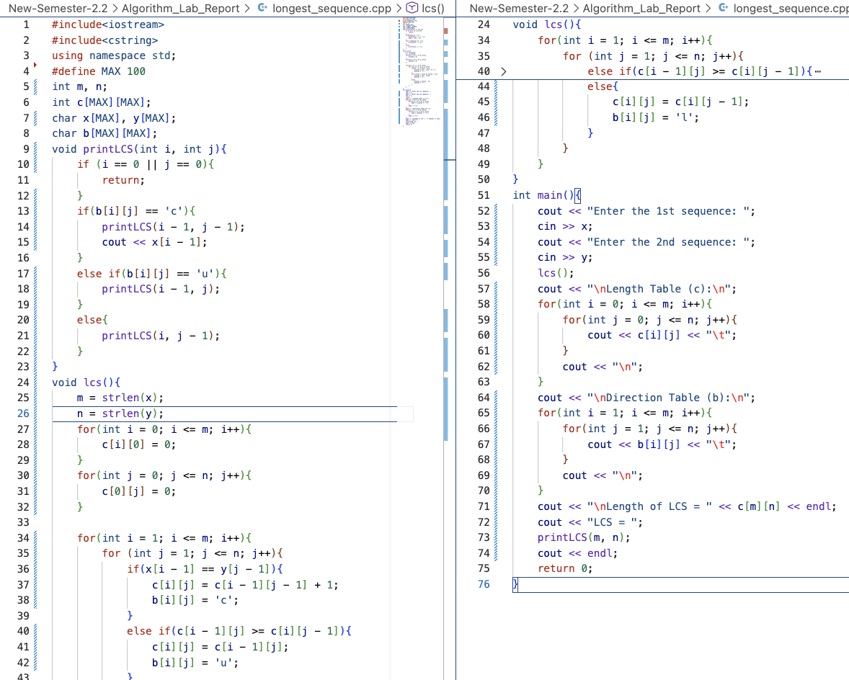

Output:
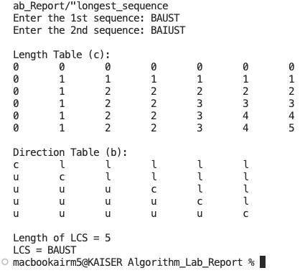

Conclusion
The implementation of the Knapsack and Longest Common Subsequence (LCS) algorithms was completed successfully using the Dynamic Programming approach. The Knapsack algorithm effectively selected the optimal combination of items to achieve the maximum possible profit within the given capacity, while the LCS algorithm correctly identified the longest common subsequence shared by two input strings. Through this experiment, a better understanding of Dynamic Programming concepts, optimization techniques, and efficient problem-solving strategies was achieved. The results obtained from multiple test cases verified the correctness of both algorithms and demonstrated their usefulness in solving practical computational problems with improved efficiency.

